Exercise 5
Marc Dotson
Customers are often analyzed based on those who have made recent purchases, frequent purchases, and spent the most. This is known as a recency, frequency, monetary (RFM) analysis. Now that we can tidy data, we can analyze customers based on recent purchases and frequent purchases. As you work, remember to sketch out what you’d like the data to look like. In RStudio on Posit Cloud, create a new Quarto document and do the following.
- Let’s define customers who have made recent purchases as anyone who has made more than 10 transactions in 2018. Report on the composition of these customers.
- Let’s define customers who have made frequent purchases as anyone who has made more than 150 transactions total. Report on the composition of these customers.
- Render the Quarto document into Word, export the Word document, and upload to Canvas.
Five points total, one point each for:
- Recode the data to identify recent customers.
- Explore the composition of recent customers and provide an explanation.
- Recode the data to identify frequent customers.
- Explore the composition of frequent customers and provide an explanation.
- Submitting a rendered Word document.

Recency
First, let’s determine which customers have made more than 10 transactions in 2018.
# Load packages.
library(tidyverse)
── Attaching core tidyverse packages ──────────────────────── tidyverse 2.0.0 ──
✔ dplyr 1.1.4 ✔ readr 2.1.4
✔ forcats 1.0.0 ✔ stringr 1.5.1
✔ ggplot2 3.4.4 ✔ tibble 3.2.1
✔ lubridate 1.9.3 ✔ tidyr 1.3.0
✔ purrr 1.0.2
── Conflicts ────────────────────────────────────────── tidyverse_conflicts() ──
✖ dplyr::filter() masks stats::filter()
✖ dplyr::lag() masks stats::lag()
ℹ Use the conflicted package (<http://conflicted.r-lib.org/>) to force all conflicts to become errors
# Import data.
crm_data <- read_csv("customer_data.csv") |>
left_join(read_csv("store_transactions.csv"), join_by(customer_id))
Rows: 10531 Columns: 13
── Column specification ────────────────────────────────────────────────────────
Delimiter: ","
chr (8): gender, married, college_degree, region, state, review_time, review...
dbl (5): customer_id, birth_year, income, credit, star_rating
ℹ Use `spec()` to retrieve the full column specification for this data.
ℹ Specify the column types or set `show_col_types = FALSE` to quiet this message.
Rows: 10531 Columns: 169
── Column specification ────────────────────────────────────────────────────────
Delimiter: ","
dbl (169): customer_id, jan_2005, feb_2005, mar_2005, apr_2005, may_2005, ju...
ℹ Use `spec()` to retrieve the full column specification for this data.
ℹ Specify the column types or set `show_col_types = FALSE` to quiet this message.
# Select transaction data for 2018, tidy, summarize purchase history,
# and filter on respondents who have made more than 10 transactions.
recent_cust <- crm_data |>
select(customer_id, contains("2018")) |>
pivot_longer(
-customer_id,
names_to = "month_year",
values_to = "transactions"
) |>
group_by(customer_id) |>
summarize(total_transactions = sum(transactions)) |>
filter(total_transactions > 10)
recent_cust
# A tibble: 4,037 × 2
customer_id total_transactions
<dbl> <dbl>
1 1010 12
2 1013 11
3 1019 16
4 1020 14
5 1021 17
6 1023 13
7 1024 11
8 1026 11
9 1029 19
10 1039 15
# ℹ 4,027 more rows
Now that we have identified which customers satisfy this definition of “recent customers,” we can use a left_join() to join the remainder of the crm_data and explore these customers’ composition.
# Join crm_data with recent_cust.
recent_cust <- recent_cust |>
left_join(crm_data, join_by(customer_id))
# Explore distributions of continuous variables.
recent_cust |>
mutate(age = 2021 - birth_year) |>
select(total_transactions, income, credit, age) |>
pivot_longer(
total_transactions:age,
names_to = "var_names",
values_to = "var_values"
) |>
ggplot(aes(x = var_values)) +
geom_histogram() +
facet_wrap(~ var_names, scales = "free")
`stat_bin()` using `bins = 30`. Pick better value with `binwidth`.
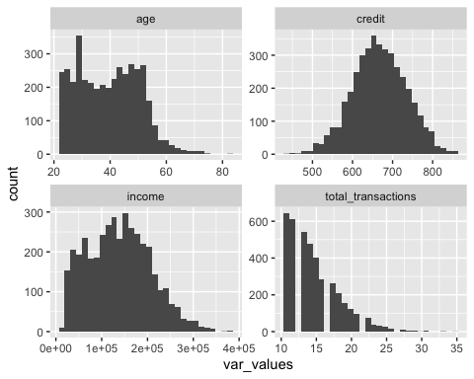
Recent customers don’t look so dissimilar from the overall customer base in terms of continuous variables: same sort of age, credit, and income distributions. In terms of total_transactions, we see a long tail above 10 transactions, up to 35.
# Explore distributions of discrete variables.
recent_cust |>
select(gender, married, college_degree, region) |>
pivot_longer(
gender:region,
names_to = "var_names",
values_to = "var_values"
) |>
ggplot(aes(x = var_values)) +
geom_bar() +
facet_wrap(~ var_names, scales = "free")
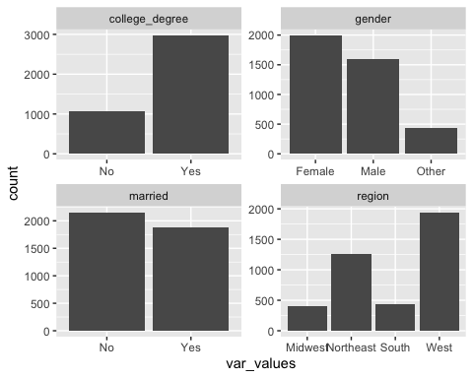
Most recent customers have a college degree, are female, and are unmarried. They appear to be fairly evenly distributed across regions, compared to the overall customer base.

Frequency
Now, let’s determine which customers have made more than 150 transactions overall.
# Tidy and summarize purchase history and filter on respondents
# who have made more than 150 transactions overall.
frequent_cust <- crm_data |>
select(customer_id, jan_2005:dec_2018) |>
pivot_longer(
-customer_id,
names_to = "month_year",
values_to = "transactions"
) |>
group_by(customer_id) |>
summarize(total_transactions = sum(transactions)) |>
filter(total_transactions > 150)
frequent_cust
# A tibble: 3,046 × 2
customer_id total_transactions
<dbl> <dbl>
1 1010 156
2 1011 169
3 1014 176
4 1016 151
5 1019 227
6 1020 187
7 1026 169
8 1032 151
9 1036 153
10 1046 168
# ℹ 3,036 more rows
Now that we have identified which customers satisfy this definition of “frequent customers,” we can use a left_join() to join the remainder of the crm_data and explore these customers’ composition.
# Join crm_data with frequent_cust.
frequent_cust <- frequent_cust |>
left_join(crm_data, join_by(customer_id))
# Explore distributions of continuous variables.
frequent_cust |>
mutate(age = 2021 - birth_year) |>
select(total_transactions, income, credit, age) |>
pivot_longer(
total_transactions:age,
names_to = "var_names",
values_to = "var_values"
) |>
ggplot(aes(x = var_values)) +
geom_histogram() +
facet_wrap(~ var_names, scales = "free")
`stat_bin()` using `bins = 30`. Pick better value with `binwidth`.
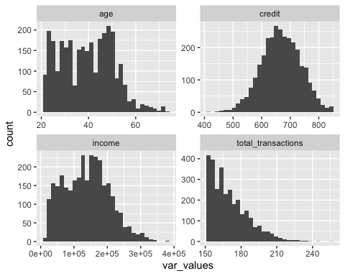
Frequent customers don’t look so dissimilar from the overall customer base in terms of continuous variables: maybe skewed slightly younger but credit and income distributed the same. In terms of total_transactions, we see a long tail above 150 transactions, up to nearly 250 transactions total.
# Explore distributions of discrete variables.
frequent_cust |>
select(gender, married, college_degree, region) |>
pivot_longer(
gender:region,
names_to = "var_names",
values_to = "var_values"
) |>
ggplot(aes(x = var_values)) +
geom_bar() +
facet_wrap(~ var_names, scales = "free")
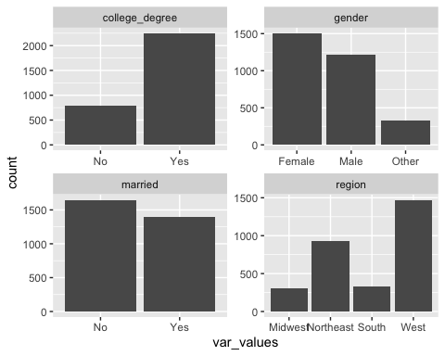
Similarly, most frequent customers have a college degree, are female, and are unmarried. They appear to be fairly evenly distributed across regions, compared to the overall customer base.

